sports
Author: Radhasahithi Challa
1. Problem Statement
Develop a Python program to store sports tournament match results and team scores, calculate total points and tie-break values, and generate team rankings according to a predefined competition policy. The program awards points for wins, draws, and losses, calculates goal difference as a tie-break value, and sorts teams to determine their final positions.
2. Objectives
- Store team names and match results.
- Record goals scored by each team in every match.
- Calculate total points earned by each team.
- Calculate goals scored, goals conceded, and goal difference.
- Rank teams based on total points and tie-break values.
- Display a final tournament ranking table.
3. Assumptions
- The tournament uses a league-based scoring system.
- Each match involves two different teams.
- A win earns 3 points.
- A draw earns 1 point for each team.
- A loss earns 0 points.
- Goal difference is calculated as goals scored minus goals conceded.
- Teams are ranked using the following order:
  - Total points, highest first.
  - Goal difference, highest first.
  - Total goals scored, highest first.
- If all ranking criteria are equal, teams are displayed alphabetically.
- Goals must be non-negative integers.
- Each match result is entered only once.
4. Algorithm
- Start the program.
- Input the number of teams and their names.
- Initialize each team's points, goals scored, and goals conceded to zero.
- Input the number of matches.
- For each match:
  - Enter the two team names.
  - Enter the goals scored by both teams.
  - Update goals scored and goals conceded for both teams.
  - Award 3 points to the winner.
  - Award 1 point to each team if the match is a draw.
  - Award no points to the losing team.
- Calculate the goal difference for each team.
- Sort teams by total points, goal difference, and goals scored in descending order.
- Use alphabetical order when all three criteria are equal.
- Display the final rankings and team statistics.
- Stop.

Flow chart
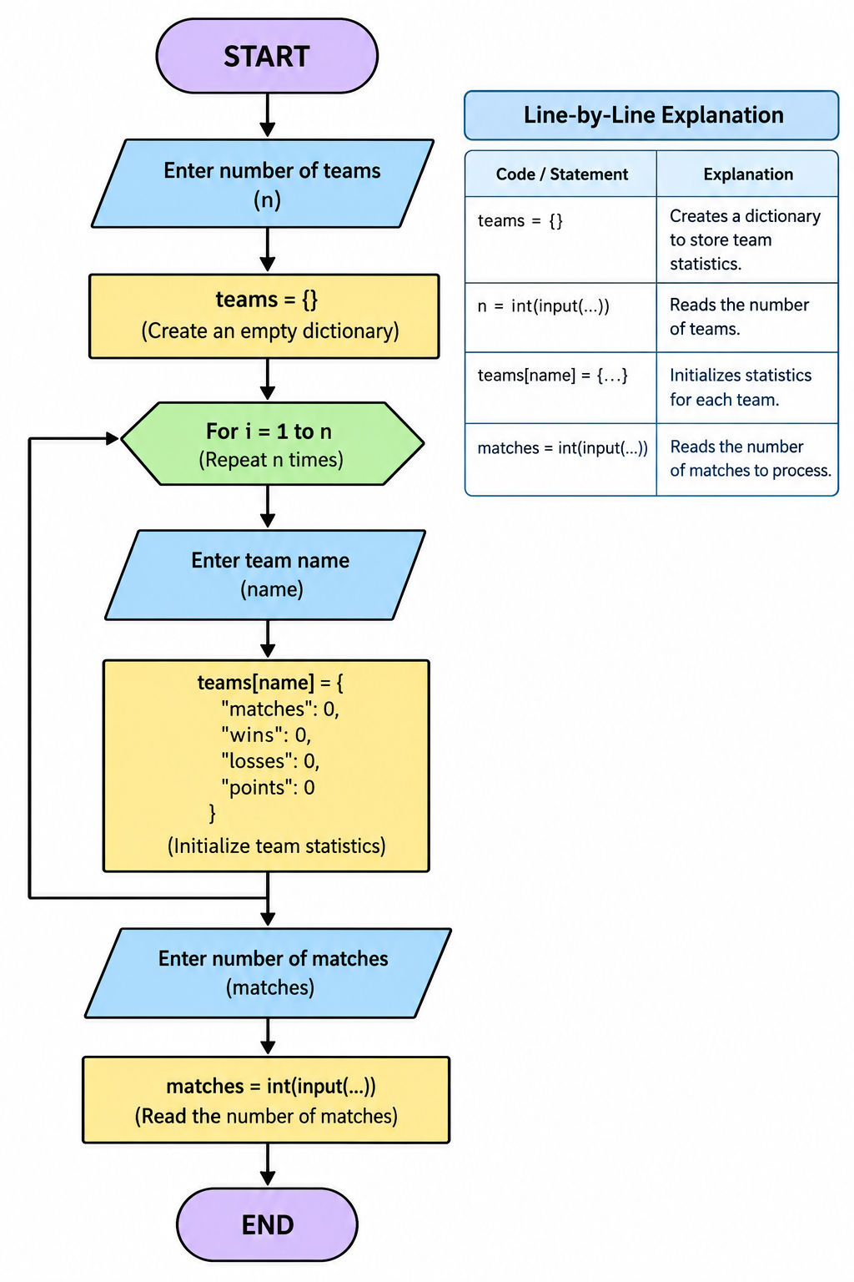
Pseudo code

INPUT number_of_teams
FOR each team:
INPUT team_name
points = 0
goals_scored = 0
goals_conceded = 0
INPUT number_of_matches
FOR each match:
INPUT team1, team2
INPUT goals1, goals2
UPDATE goals_scored for both teams
UPDATE goals_conceded for both teams
IF goals1 > goals2:
team1_points = team1_points + 3
ELSE IF goals2 > goals1:
team2_points = team2_points + 3
ELSE:
team1_points = team1_points + 1
team2_points = team2_points + 1
FOR each team:
goal_difference = goals_scored - goals_conceded
SORT teams BY:
points descending
goal_difference descending
goals_scored descending
team_name ascending
DISPLAY final rankings
END
8. Line-by-Line Explanation
Code / statement | Explanation
teams = {} | Creates a dictionary to store team statistics.
n = int(input(...)) | Reads the number of teams.
teams[name] = {...} | Initializes statistics for each team.
matches = int(input(...)) | Reads the number of matches to process.
for i in range(matches): | Processes each match one by one.
team1 and team2 | Store the names of the two participating teams.
goals1 and goals2 | Store the goals scored by each team.
teams[team1]["played"] += 1 | Increases the number of matches played by the first team.
teams[team1]["gf"] += goals1 | Adds the first team's goals scored.
teams[team1]["ga"] += goals2 | Adds the goals conceded by the first team.
if goals1 > goals2: | Checks whether the first team won.
teams[team1]["points"] += 3 | Awards three points to the winner.
elif goals2 > goals1: | Checks whether the second team won.
else: | Handles a drawn match and awards one point to each team.
sorted(...) | Orders teams according to the competition policy.
gd = data["gf"] - data["ga"] | Calculates goal difference.
enumerate(ranking, start=1) | Assigns rank numbers beginning at 1.
print(...) | Displays the final tournament table.
9. Test Cases
Test | Match result | Expected points | Expected outcome
1 | Tigers 2–0 Lions | Tigers: 3, Lions: 0 | Tigers ranked higher
2 | Eagles 1–1 Hawks | Eagles: 1, Hawks: 1 | Both receive one point
3 | Bears 0–3 Wolves | Bears: 0, Wolves: 3 | Wolves ranked higher
4 | Red 2–0 Blue; Red 1–2 Green | Red: 3, Blue: 0, Green: 3 | Red and Green are compared by goal difference
5 | Alpha 1–0 Beta; Beta 2–1 Alpha | Alpha: 3, Beta: 3 | Equal points and goal difference; goals scored break the tie
6 | Fewer than two teams | None | Program displays a validation message
10. Sample Output
Enter number of teams: 3
Enter team 1 name: Tigers
Enter team 2 name: Lions
Enter team 3 name: Eagles
Enter number of matches: 3

Match 1
Enter first team name: Tigers
Enter second team name: Lions
Goals by Tigers: 2
Goals by Lions: 0

Match 2
Enter first team name: Eagles
Enter second team name: Tigers
Goals by Eagles: 1
Goals by Tigers: 1

Match 3
Enter first team name: Lions
Enter second team name: Eagles
Goals by Lions: 0
Goals by Eagles: 3
Rank Team P W D L GF GA GD Pts
1 Eagles 2 1 1 0 4 1 3 4
2 Tigers 2 1 1 0 3 1 2 4
3 Lions 2 0 0 2 0 5 -5 0

My output
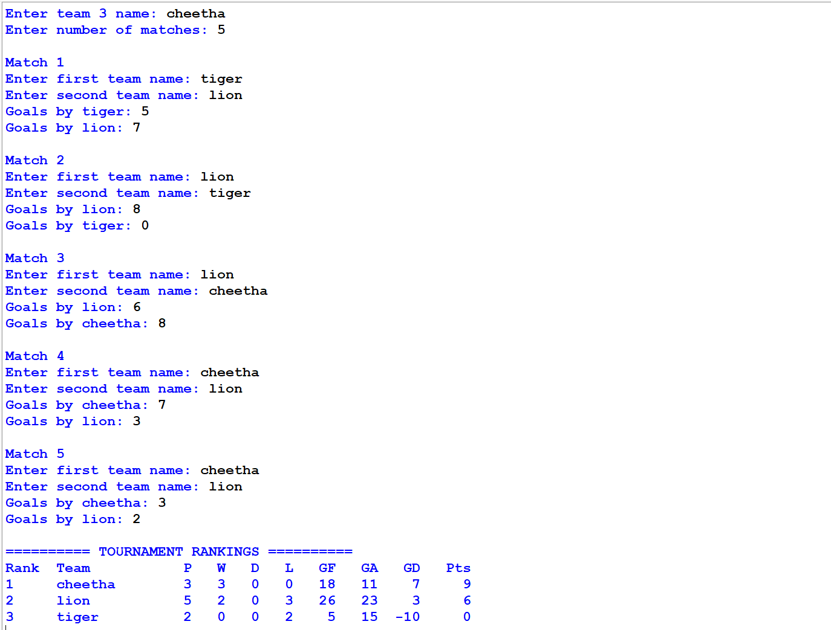

11. Conclusion
The Sports Tournament Ranking System automates the calculation of team points, match statistics, goal differences, and final rankings. By applying a consistent competition policy, it provides an organized and transparent way to determine team positions. The program can be extended to support additional tie-break rules, multiple sports, and tournament formats.

